10 MB file:

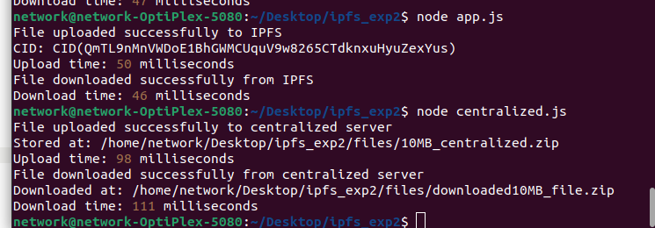

20MB file:

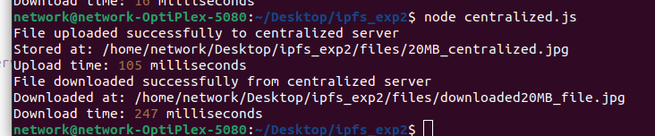

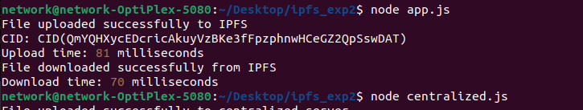

40MB



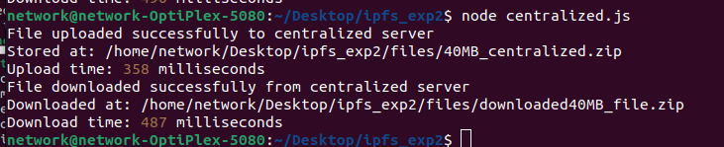

60MB



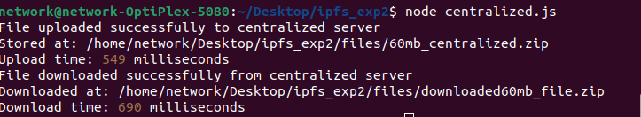

80MB



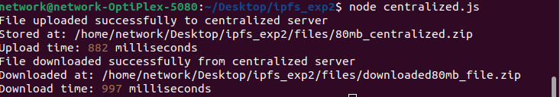

100MB

